Shenandoah First United Methodist Church
October 26, 2025
20th Sunday after Pentecost

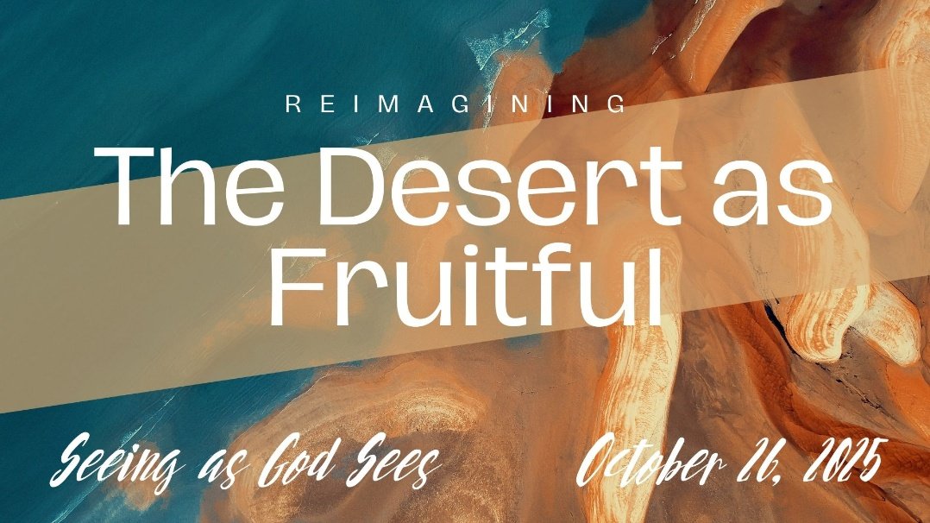

We are glad you’re with us today. Thank you for joining us in this celebration of God’s love for you. We pray this time will uplift you in your spiritual walk, and you will feel God’s presence here today in this place. May you always find us to be a church faithful to God and ready to help you in your walk with Jesus Christ.

If you are new or returning after a long absence, please fill out one of the welcome cards in the pew or our One Church app so that we can make our Next Connection with you. We wear name tags to help make those connections. Want one? Contact the office by phone or email. NOTICE: We live stream our worship service with video.

The lyrics to all the songs and the congregational responses will be on our screens. The * indicates standing, if able.
Our Vision: “Growing as disciples of Jesus while connecting with others and serving our community.

Sunday Worship Service
October 26, 2025
20th Sunday after Pentecost

Order of Worship
*PRELUDE - LIGHTING the CANDLES
*Call to Worship
*Sing | “O Spirit of the Living God” | #539 (Hymnal)
*Prayer of Invocation
*Welcome & Announcements
*Sing | “Beautiful Things” |  |  |  | (Screens)
Choir/Offering |  | “Home on the Rock”
Offering & Response |  |  | “Doxology” | #95 (Hymnal)
Children’s Message
Prayers of the People-Joys & Concerns
L: Lord in your Mercy P: Hear our prayer
The Lord’s Prayer
Scripture Isaiah 32:12-20
Message | “Reimagining the Desert as Fruitful” | Pastor David Clark
*Sing | “Breathe on Me, Breath of God” |  | #420 (Hymnal)
*Benediction
**Recessional | “Change My Heart, O God” | #2152 (Black)
** Join us after service downstairs in the Fellowship Hall for coffee, refreshments, and Fellowship.

Birthdays & Anniversaries this week
30th – Jodi Anderzhon, Gary Milstead
Announcements & Opportunities to Serve
Office Closed – Tuesday at 11:00-1:00
Church Doors – all doors will be locked within this next week after the Ring doorbell is installed. You will need to ring, and Jeff will let you in the building. The doors will be unlocked for special events like mat making and bible study.
Cookies/Treats – are needed for fellowship time after service each week and right now running low. If anyone could help to replenish cookies/treats it would be appreciated. There is also a sign-up book downstairs if you would like to volunteer to oversee fellowship time on a particular Sunday.
Southwest Charge Conference – Sunday, November 2nd from 2-4 pm, Sidney United Faith, Sidney, IA.
PK-6 & Jr/Sr High Sunday School – PK-6 after the children’s message and Jr/Sr High at 10:30 a.m.
Bible Study with Pastor David –Wednesdays at 11:00 a.m.
Chancel & Bell Choirs – Wednesdays-bells at 4:30 pm and choir at 5:30 pm
Noisy Offering – last Sunday in October for the Hispanic Center.
Meals on Wheels – volunteers are needed to help with delivering meals on Thursdays. A sign-up sheet is located on the counter of the Welcome Center.
Fellowship Time – Sign-up sheets to host & provide treats after service are located downstairs.
Food Pantry Needs for November – Spaghetti Sauce and Pasta (any type), Chili, Chunky Style Soup, Mandarin Oranges, Green Beans, Corn, Spinach, Sauerkraut, Beets, Gravy Packets, Potato Flakes, Soda, Graham and Snack Crackers, Brownie, Cake, Muffin and Cookie Mixes, Hot Chocolate Mix, Microwave Popcorn, Dish and Laundry Soap.
If you’re interested in joining this church, you can do so through a Profession of Faith or by Transfer from another church.
Our church software is at https://shenchurch.onechurchsoftware.com or you can download the One Church app on your smartphone.

Smile – Please note that photography & video recording may be in progress while you are here, and entry into the church signifies your release & consent to the possibility that your image may be used by Shenandoah First United Methodist Church for promotional purposes.

Praise Team: Terry Stafford (piano), Linda Haldane (keyboards), Margaret Brady (cello), Deb Finlay, Jeff Hiser, Pastor David (vocals)
Last Week’s Attendance
In-Person Worship – 73 On-Line Worship – 15
Find the latest info, including online giving, recordings of recent services, and daily devotions, at our website: https://shen.church
200 Church St, PO Box 394, Shenandoah, IA 51601
712-246-2081 - office@shen.church
Pastor David B. Clark - pastordavid@shen.church – 308-258-7749

Call to Worship
Leader: The desert blooms when the Spirit is poured out.
People: Our emptiness becomes ground for God’s new life.
L: In the wilderness, justice takes root.
P: In the barren field, peace begins to grow.
L: Come, people of God, with open hearts.
P: We come to worship the One who makes all things fruitful.

Putting it Into Practice

Rest: When we experience the desert in our lives, sometimes the best thing we can do is just to simply rest. Be still and know that God is God. (Growing as disciples)

Walking through the desert with others: Notice if there are others in your life who are in a desert season. How can you walk with them? (Connecting with others)

Learning from your desert experience: Desert experiences have something to teach us if we listen. Can your desert, such as loneliness, grief, or illness, be transformed into a gift for others? (Serving our community)

